**Urban-Noise-Level-Analytics-MySQL**

This project analyses urban noise data using structured SQL to derive actionable insights for city planners and environmental agencies. It uses data from sensors installed across multiple areas, events organized in those regions, and noise readings collected over time.  
  
  
-- 📊 Data Exploration & Cleaning – Urban Noise Analytics  
  
**1. Total Records in Each Table**

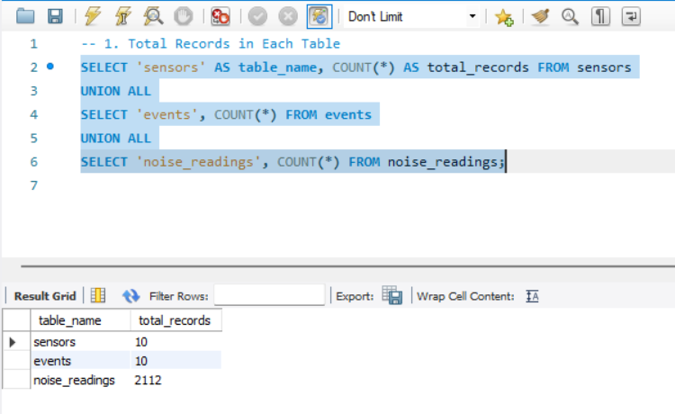  
  
  
**2. Time Range of Noise Readings**  
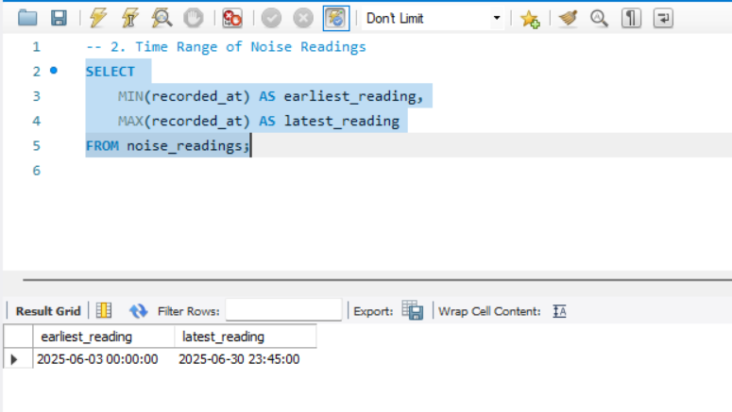

**3. Number of Sensors per Area**  
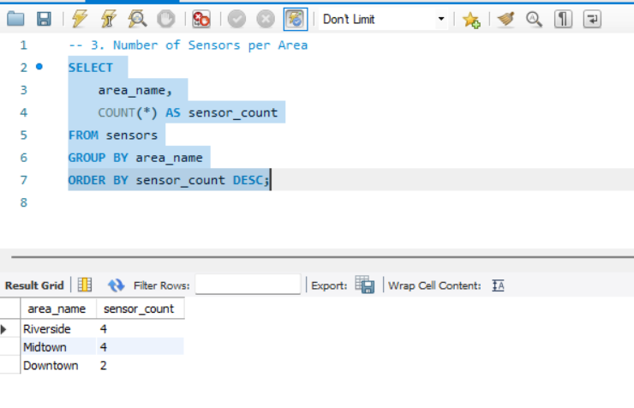  
  
**4. Number of Events per Area and Event Type**  
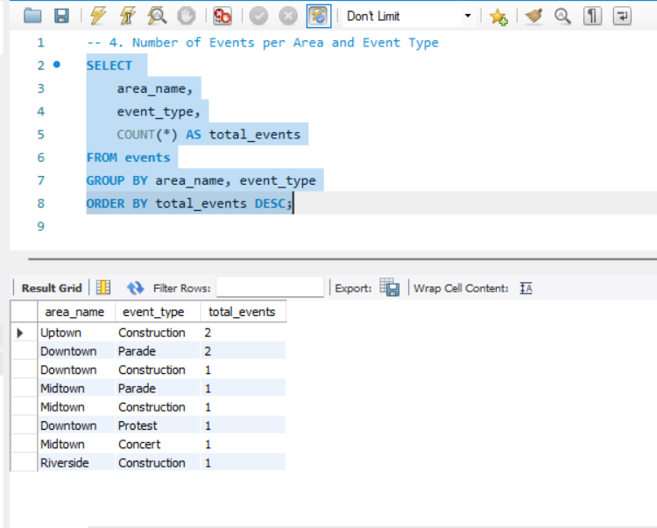

**5. Readings Per Sensor**  
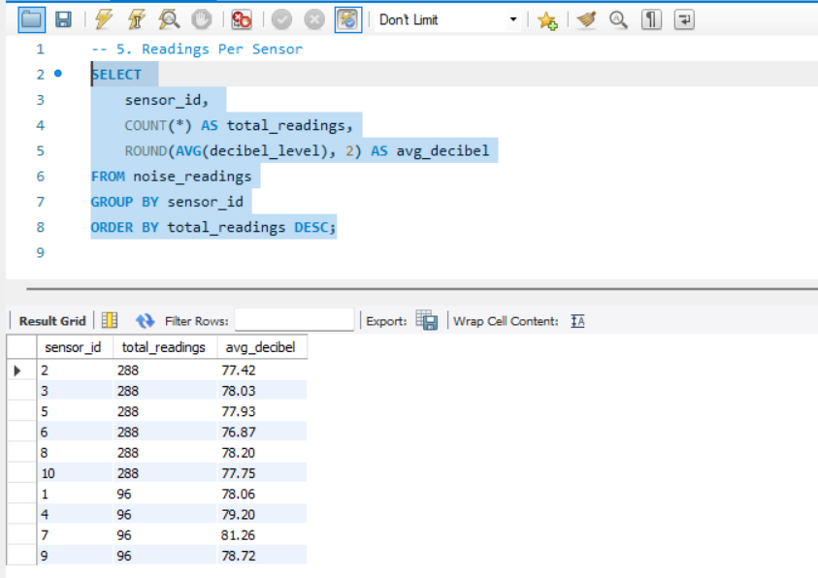

**6. Sensors Without Readings**

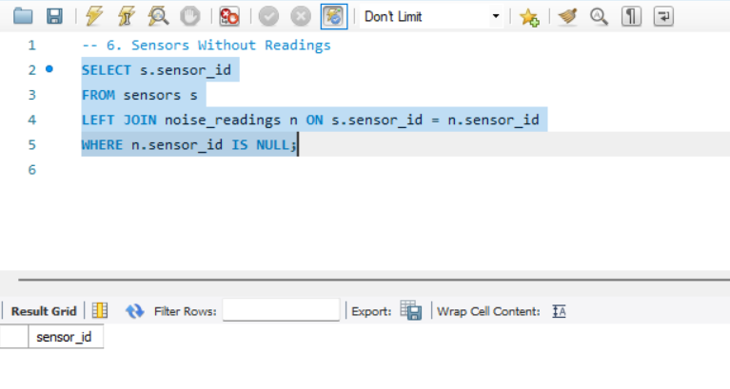

**7. NULL Value Check in Noise Readings**

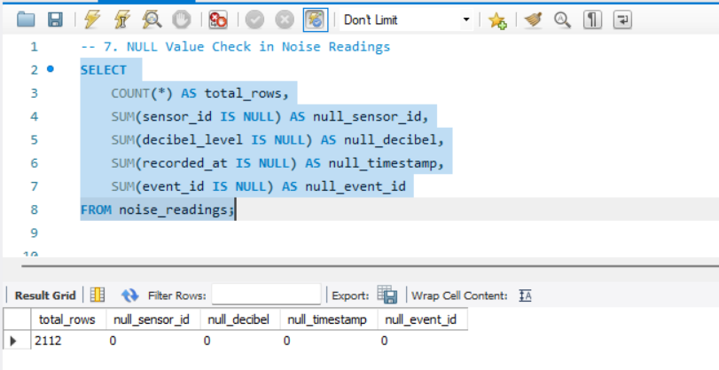

**8. Check for Outliers in Decibel Levels**

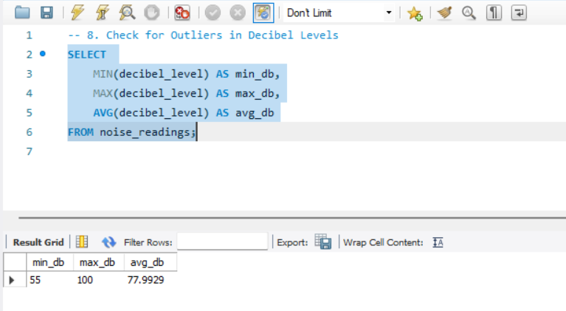

**9. Identify Suspicious Readings (<30 or >130 dB)**

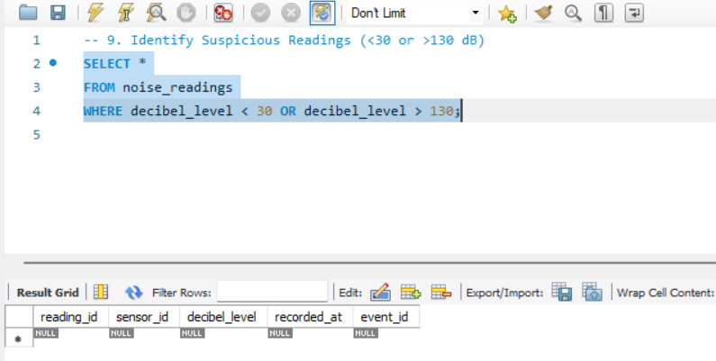

**10. Orphan Records: Missing Sensor/Event References**

**a) Readings referencing missing sensors**

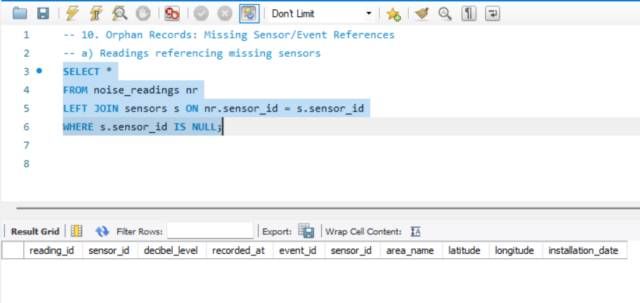

**b) Readings referencing missing events**

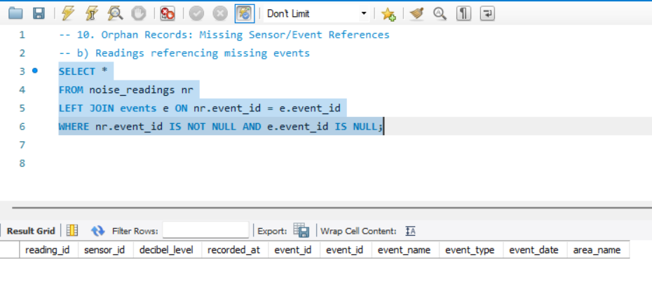

**11. Future Dated Readings**